Swarm Intelligence
Designed by QiLin.
Teaching aims:
1. Know about swarm intelligence.
2. Improve students' reading ability.
3. Encourage students' team work.
Teaching procedure.
- Pre-reading.
Predict: What will the passage talk about?
___________________________________________________________
- While-reading.
- Look through the passage and divide it into three parts.
2.Find out the main idea.
part1 (para.- ) ____A. The definition and an example of swarm intelligence.
part2( para.- )_____B. Scientists believe ants may help us solve some problems.
part3 (para.- )______C. Scientists hope to use swarm intelligence to help us solve some problems.
3.Read paragraph 2 and 3, and explain the swarm intelligence .
___________________________________________________________
4.Read paragraph4 and put them in right order.
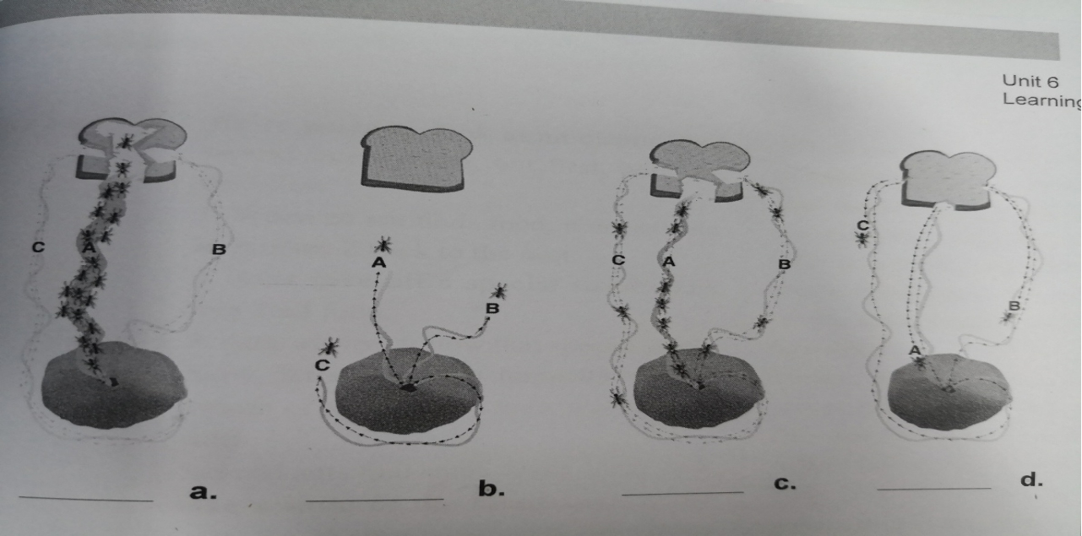
拓展材料
Bionic Robots
Bionic gecko (壁虎). A flexible bionic robot that can climb walls, cross over obstacles, and stick to surfaces has been successfully developed by Chinese scientists. They get inspiration from the gecko. The project was established in 2016, when most glass walls of office buildings were cleaned by humans, which is both difficult and dangerous. The research team hopes the robot can help solve this problem. The robot, weighing 5 kilograms with a length of less than 1 meter, is of potential use for inspection（侦查） and exploration in different environments.
Bionic fish. A team of students from Taiwan developed a robot fish that could predict extreme weather conditions using existing data, including ocean currents and temperature, and transmit(传送） its forecast to meteorological workers through a WiFi connection.
Bionic ants. It looks very similar to the real ants, but the overall size is much larger than the real ants, about 13cm. The head is equipped with a camera, and can be used for rescuing in earthquakes and detection in extreme environments. They can also get together to move huge objects, having the spirit of real ants.
In a word, these bionic robots can complete some difficult tasks that humans can not. They will help us solve some problems in different fields.
Look through the passage and answer:
1. How many bionic robots are mentioned？
2. What problems can they solve?
III. Post-reading.
Discussion:
Supposing your group will go to Beijing to participate in a Bionic Robot Competition next month. Now you discuss within your group.
1. What bionic robot will you design ?
2. Where do you get your inspiration?
3. What problems will your robot solve?
____________________________________________________________________________________________________________________________________________________________________________________________________________________________________________________________________________________________________________________________________________________________________________________________________________________________________________________________________________________________________________________________________________________________________________________________________________________________________________________________ _____________
Think deeply:
What other inventions are inspired by the nature? How do we treat the mother nature? What should you do as students?
________________________________________________________ ___
____________________________________________________________________________________________________________________________________________________________________________Homework
Perfect your discussion and write it down on your exercise book.

