How to polish up our writing
﹡学习目标：
1．To learn the strategies of improving our writing sheet.
2．To practice by evaluating, assigning a topic, writing in class and polishing up.
﹡学习过程：
I．How to evaluate an essay——怎么评？
* 我来评——Group work
Instruction：Suppose you are a teacher and exam-marker. Please work in groups of four, grade the following essays, and tell why.
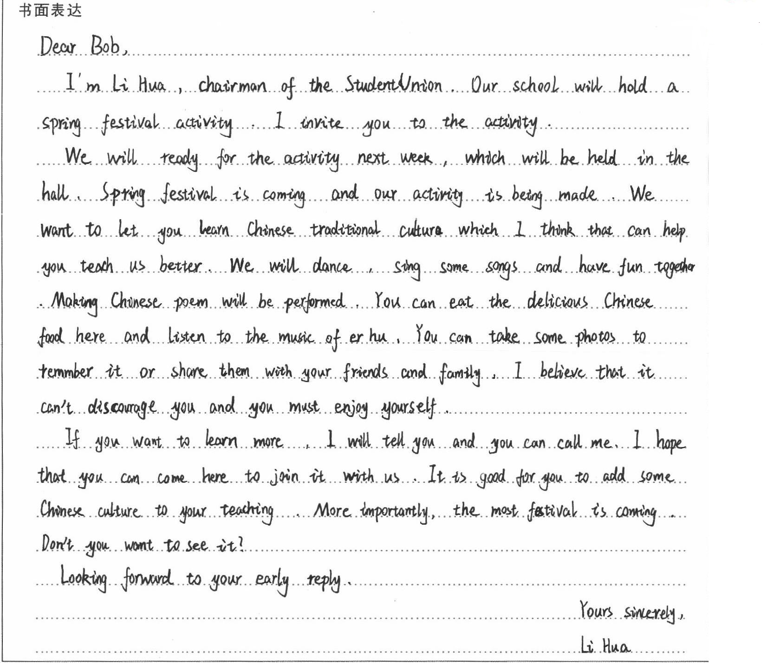

Score:
Evaluation:

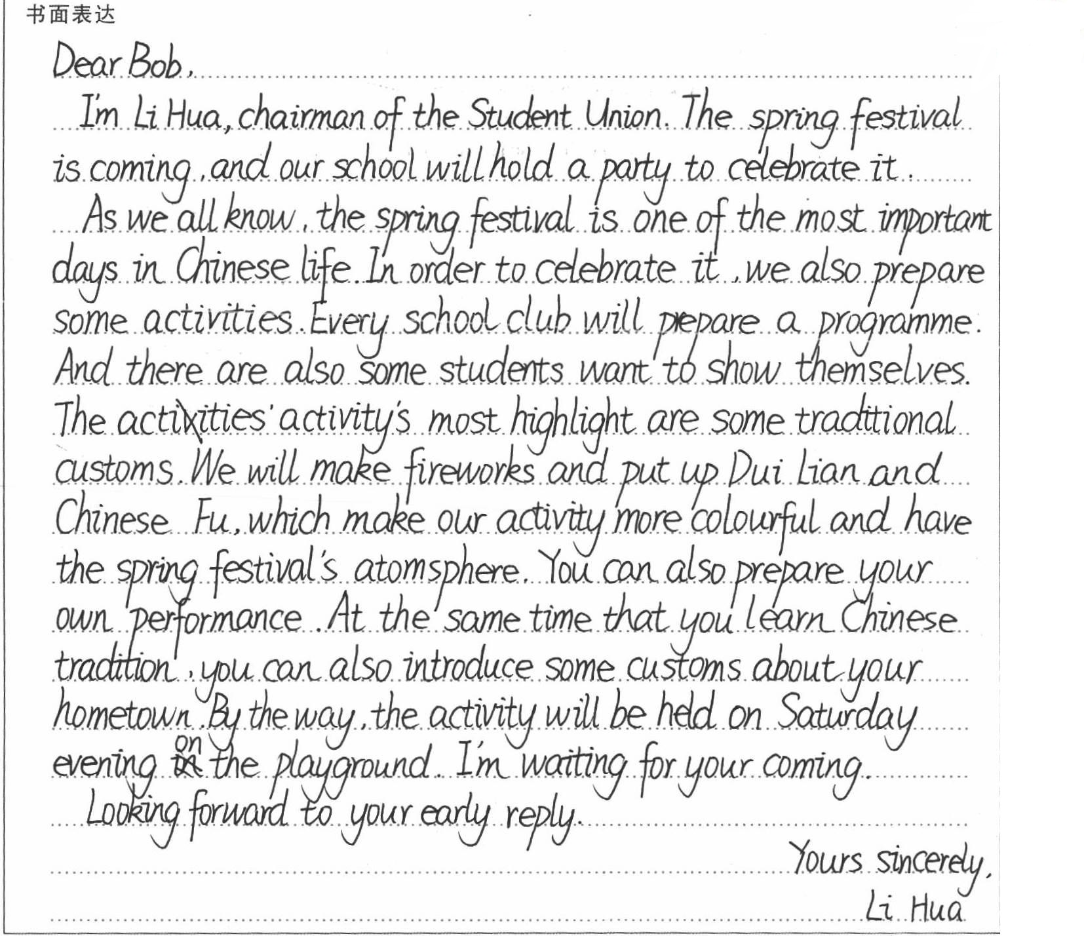

Score:
Evaluation:

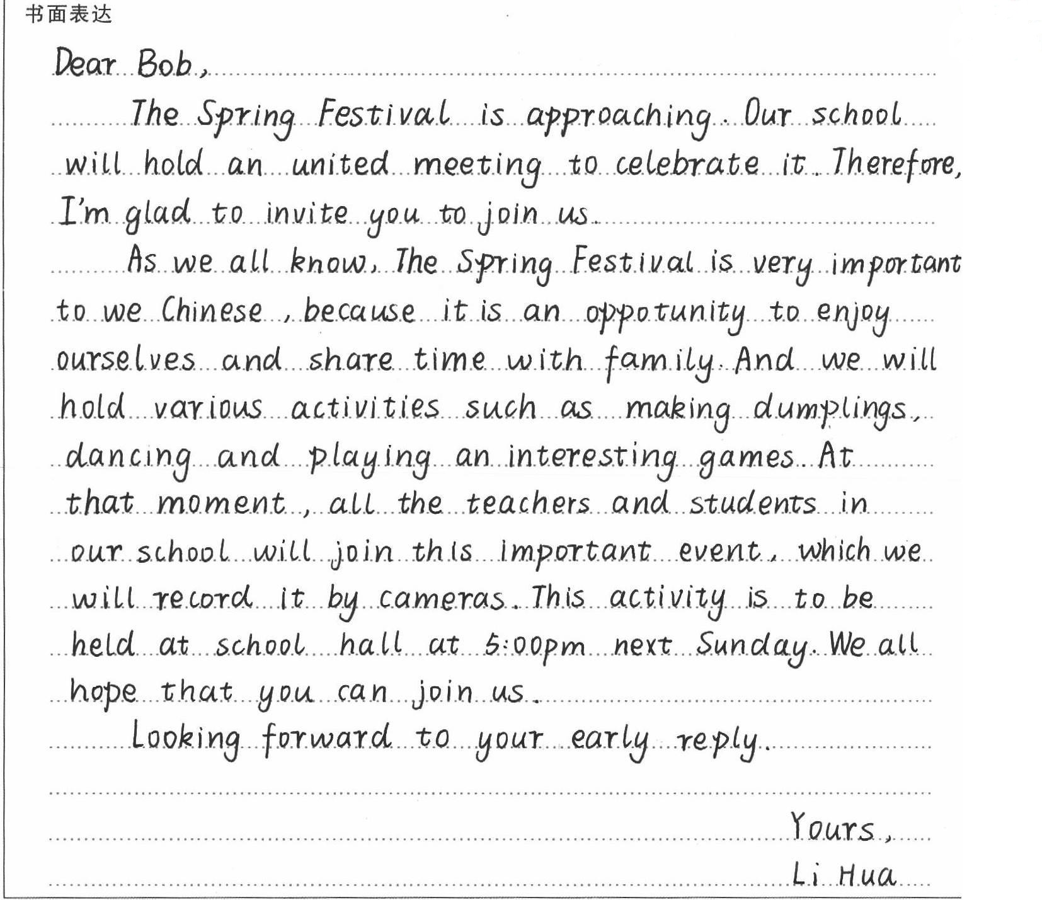

Score:
Evaluation:

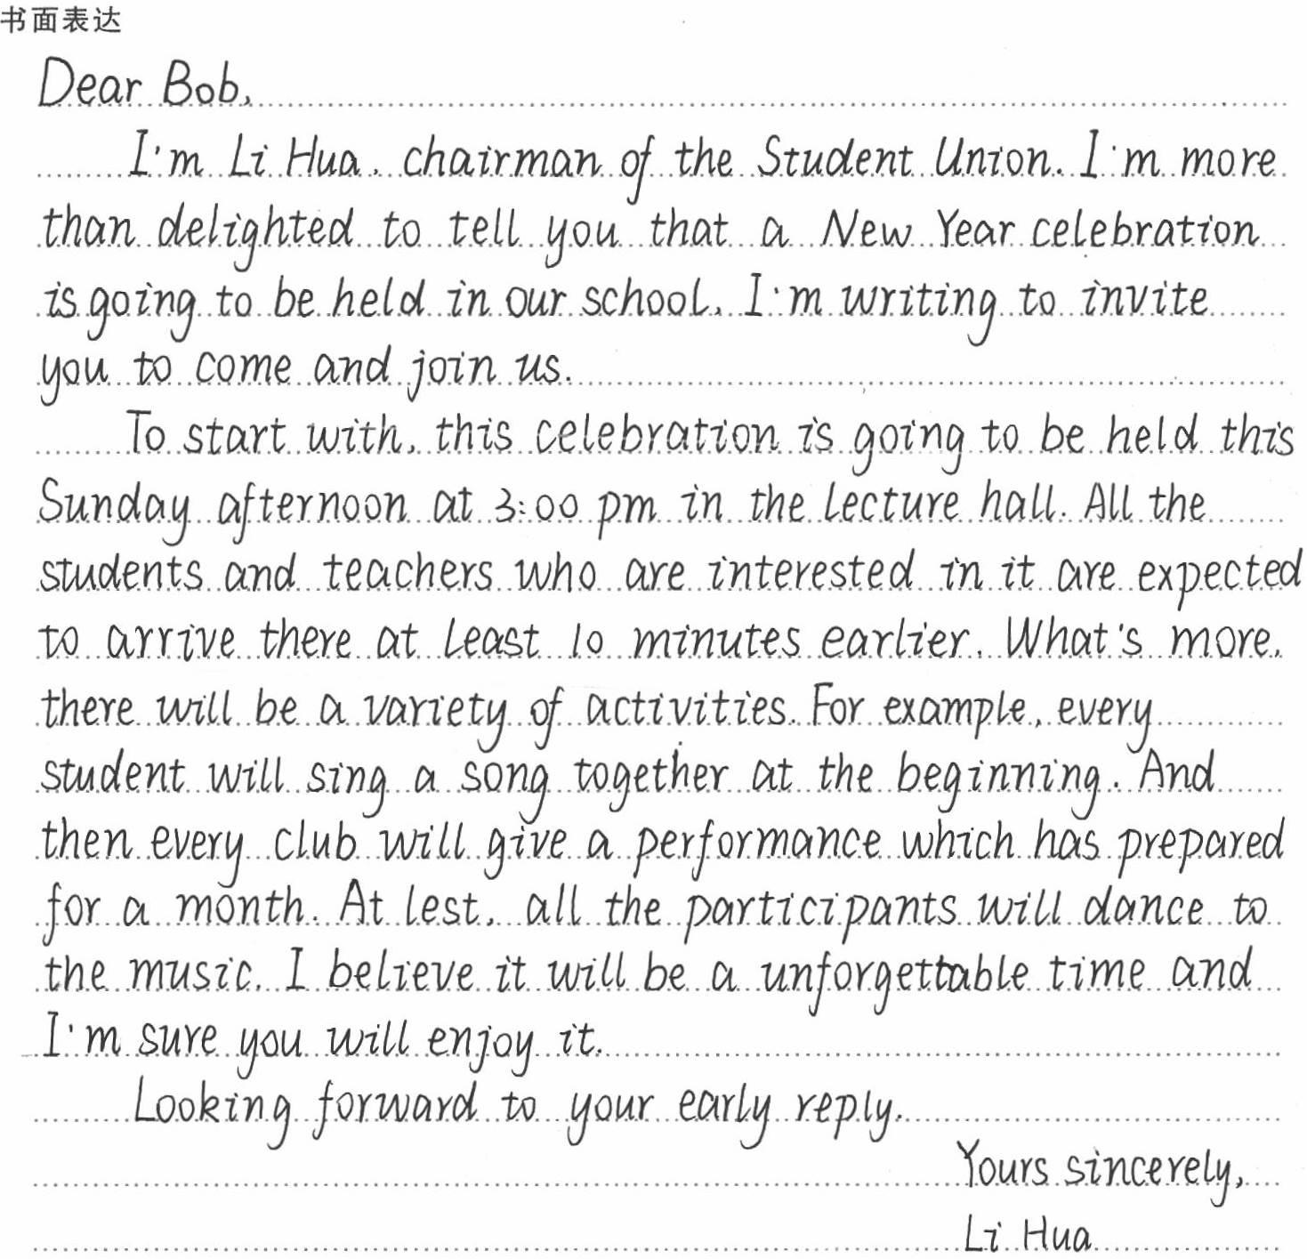

Score:
Evaluation:
* 思考：
对比“小老师们”和阅卷老师的评分后可以发现，考场作文评价的主要方面是_____________________

II．How to assign a topic——怎么考？
* 高考书面表达的考查规律：
1．应用文
2．以考查英语实际应用能力为主
3．尤其是书信，如求助信、约稿信、投诉信、邀请信、咨询信、自荐信等
4．贴近学生生活，现实感强，情景逼真
5．重视创设情境，让考生有更大的自由发挥空间
* 我来考——Individual work
研读《书面表达》专题“考情概览”及“真题和适应性试题”部分，感受命题规律，小试牛刀，为“2019年高考全国卷I”书面表达部分命题。Come on！力争创造出一个优质考题。
__________________________________________________________________________________________________________________________________________________________________________________________________________________________________________________________________________________________________________________________________________________________________________________________________________________________________________________________________________________________________________________________________________________________________________________________________________________________
III．How to make a good essay——怎么写？
* 我来写——Individual work
Choose one from the exercises that we have created. Challenge ourselves and try to write a good essay. Be quick, quick and make a high-quality paragraph!
______________________________________________________________________________________________________________________________________________________________________________________________________________________________________________________________________________________________________________________________________________________________________________________________________________________________________________
IV．How to polish up——怎么优化？
* 我来优化——Class work & Pair work
1．Handwriting
2．Structure
3．Language
* 示之以范：精品命题选
假定你是李华，你校将于下周末举行一次书法展览，请给你的外籍教师Alex写封邮件，邀请他来参加。内容包括：
1．活动的时间与地点；
2．活动的主要内容；
3．询问是否有空参加。

注意：
- 词数100左右；
- 可适当增加细节，以使行文连贯。
参考词汇：书法 calligraphy
* A sample:
Dear Alex,
I'm writing to invite you to come to the calligraphy exhibition.
It will be held next weekend. It will be in the art building. It will show some good calligraphy works. They are written by some teachers, students and several calligraphers. There are different styles of calligraphy. I don't know if you can come.
I'm looking forward to your reply.
Yours,
Li Hua
* Score：15分
* 如何优化，实现最大增值？
Tips:
- 问候语、礼貌用语
- 得体的高级词汇
- 非谓语动词、定语从句、doing做主语、There be句型、被动语态、强调句、状语从句......
________________________________________________________________________________________________________________________________________________________________________________________________________________________________________________________________________________________________________________________________________________________________________________________________________________________________________________________________________________________________________________________________________________________________________________________________________________________________________________________________________________________________________________

V．A poem for you:
ON WRITING
Neat and tidy,
Clear structure and proper strategies,
Makes a perfect writing sheet.
We can't be too careful.
We can't be too good at writing.
So, step by step,
Polish up our essays.
Pursue a higher quality!
VI．Assignment

