**E-Waste**

***--Reading for Writing***

***By Jin shumin***

**Passage A**（2018全国I卷D)

We may think we’re a culture that gets rid of our worn technology at the first sight of something shiny and new, but a new study shows that we keep using our old devices (装置) well after they go out of style. That’s bad news for the environment—and our wallets—as these outdated devices consume much more energy than the newer ones that do the same things.

To figure out how much power these devices are using, Callie Babbitt and her colleagues at the Rochester Institute of Technology in New York tracked the environmental costs for each product throughout its life—from when its minerals are mined to when we stop using the device. This method provided a readout for how home energy use has evolved since the early 1990s. Devices were grouped by generation. Desktop computers, basic mobile phones, and box-set TVs defined 1992. Digital cameras arrived on the scene in 1997. And MP3 players, smart phones, and LCD TVs entered homes in 2002, before tablets and e-readers showed up in 2007.

As we accumulated more devices, however, we didn’t throw out our old ones. “The living-room television is replaced and gets planted in the kids’ room, and suddenly one day, you have a TV in every room of the house,” said one researcher. The average number of electronic devices rose from four per household in 1992 to 13 in 2007. We’re not just keeping these old devices—we continue to use them. According to the analysis of Babbitt’s team, old desktop monitors and box TVs with cathode ray tubes are the worst devices with their energy consumption and contribution to greenhouse gas emissions (排放) more than doubling during the 1992 to 2007 window.

So what’s the solution? The team’s data only went up to 2007, but the researchers also explored what would happen if consumers replaced old products with new electronics that serve more than one function, such as a tablet for word processing and TV viewing. They found that more on-demand entertainment viewing on tablets instead of TVs and desktop computers could cut energy consumption by 44%.

1. What does the author think of new devices?

A. They are environment-friendly.

B. They are no better than the old.

C. They cost more to use at home.

D. They go out of style quickly.

2. Why did Babbitt’s team conduct the research?

A. To reduce the cost of minerals.

B. To test the life cycle of a product.

C. To update consumers on new technology.

D. To find out electricity consumption of the devices.

3. Which of the following uses the least energy?

A. The box-set TV. B. The tablet.

C. The LCD TV. D. The desktop computer.

4. What does the text suggest people do about old electronic devices?

A. Stop using them. B. Take them apart.

C. Upgrade them. D. Recycle them.

5. What is the bad news mentioned in the first paragraph?

_____________________________________________________________

6. What are the problems of keeping using the old devices?

______________________________________________________________________________________________________________________________

7.What is the solution ?

_______________________________________________________________

**Passage B**（2015江苏阅读理解B篇）

In the United States alone, over 100 million cell-phones are thrown away each year. Cell-phones are part of a growing mountain of electronic waste like computers and personal digital assistants. The electronic waste stream is increasing three times faster than traditional garbage as a whole.

Electronic devices contain valuable metals such as gold and silver. A Swiss study reported that while the weight of electronic goods represented by precious metals was relatively small in comparison to total waste, the concentration (含量) of gold and other precious metals was higher in So-called e-waste than in naturally occurring minerals.

Electronic wastes also contain many poisonous metals. Even when the machines are recycled and the harmful metals removed, the recycling process often is carried out in poor countries, in practically uncontrolled ways which allow many poisonous substances to escape into the environment.

Creating products out of raw materials creates much more waste material, up to 100 times more, than the material contained in the finished products. Consider again the cell-phone, and imagine the mines that produced those metals, the factories needed to make the box and packaging(包装) it came in. Many wastes produced in the producing process are harmful as well.

The U.S. Environmental Protection Agency notes that most waste is dangerous in that “the production, distribution, and use of products — as well as management of the resulting waste — all result in greenhouse gas release.” Individuals can reduce their contribution by creating less waste at the start — for instance, buying reusable products and recycling.

In many countries the concept of extended producer responsibility is being considered or has been put in place as an incentive (动机) for reducing waste. If producers are required to take back packaging they use to sell their products, would they reduce the packaging in the first place?

Governments’ incentive to require producers to take responsibility for the packaging they produce is usually based on money. Why, they ask, should cities or towns be responsible for paying to deal with the bubble wrap (气泡垫) that encased your television?

From the governments’ point of view, a primary goal of laws requiring extended producer responsibility is to transfer both the costs and the physical responsibility of waste management from the government and tax-payers back to the producers.

8. By mentioning the Swiss study, the author intends to tell us that _________ .

A. the weight of e-goods is rather small

B. E-waste deserves to be made good use of

C. natural minerals contain more precious metals

D. the percentage of precious metals is heavy in e-waste

9. The responsibility of e-waste treatment should be extended _________ .

A. from producers to governments B. from governments to producers

C. from individuals to distributors D. from distributors to governments

10. What does the passage mainly talk about?

A. The increase in e-waste. B. The creation of e-waste.

C. The seriousness of e-waste. D. The management of e-waste.

11. What is the fact mentioned in the first paragraph?

_______________________________________________________________

12.What are the problems mentioned in paragragh 3、4and 5?

_______________________________________________________________

13. What are the solutions?

______________________________________________________________________________________________________________________________

**Extended reading**

**China: The electronic wastebasket of the world**

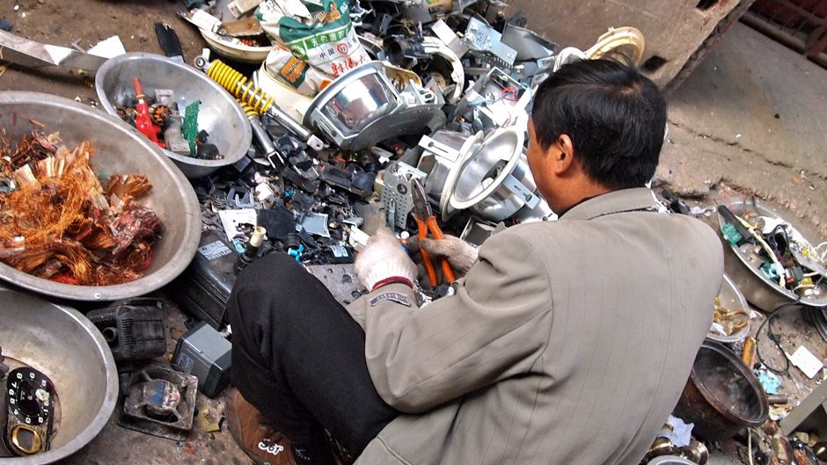

Did you ever wonder what happens to your old laptop or cellphone when you throw it away?

Chances are some of your old electronic junk will end up in China.

According to a [recent United Nations report](http://ourworld.unu.edu/en/assessing-and-improving-the-e-waste-problem-in-china/), "China now appears to be the largest e-waste dumping site in the world."

E-waste, or electronic waste, consists of everything from scrapped(报废的) TVs, refrigerators and air conditioners to that old desktop computer that may be collecting dust in your closet.

Many of these devices were initially manufactured in China. Through a strange twist of global economics, much of this electronic junk returns to China to die.

"According to United Nations data, about 70% of electronic waste globally generated ended up in China," said Ma Tianjie, a spokesman for the Beijing office of Greenpeace.

"Much of the e-waste comes through illegal channels because under United Nations conventions, there is a specific ban on electronic waste being transferred from developed countries like the United States to countries like China and Vietnam."

For the past decade, the southeastern town of Guiyu, located in China's main manufacturing zone, has been a center for the disposal（处理） of e-waste. Hundreds of thousands of people here have become experts at taking apart the world's electronic junk.

This may be one of the world's largest informal recycling operations for electronic waste. In one family-run garage, workers seemed to specialize in sorting plastic from old televisions and cars into different baskets.

But recycling in Guiyu is dirty, dangerous work. "When recycling is done properly, it's a good thing for the environment," said Ma, the Greenpeace spokesman in Beijing.

"But when recycling is done in primitive ways like we have seen in China with the electronic waste, it is hugely destructive for the local environment."

According to the April 2013 U.N. report "E-Waste in China," Guiyu suffered an "environmental disaster" as a result of the wide-scale e-waste disposal industry in the area.

Much of the toxic pollution comes from burning circuit boards, plastic and copper wires, or washing them with hydrochloric acid to recover valuable metals like copper and steel. In doing so, workshops contaminate (污染，弄脏)workers and the environment with toxic heavy metals like lead, beryllium and cadmium, while also releasing hydrocarbon ashes into the air, water and soil, the report said.

For first-time visitors to Guiyu, the air leaves a burning sensation in the eyes and nostrils.

Studies by the Shantou University Medical College revealed that many children tested in Guiyu had higher than average levels of lead in their blood, which can stunt the development of the brain and central nervous system.

The Chinese government had some success regulating e-waste disposal with a "Home Appliance Old for New Rebate Program"

With the help of generous government subsidies, the program collected tens of millions of used home appliances, according to the U.N.

Even if Chinese authorities succeed in limiting smuggled(走私) supplies of foreign garbage, the U.N. warns that the country is rapidly generating its own supply of e-waste.

"Domestic generation of e-waste has risen rapidly as a result of technological and economic development," the U.N. reported. Statistics show a great increse in sales of TV's, refrigerators, washing machines, air conditioners and computers in China over a 16-year period. In 2011, Chinese consumers purchased 56.6 million televisions, 58.1 million refrigerators, 53.0 million washing machines, 94.8 million air conditioners and 73.9 million computers, in addition to 250 million mobile phones. In the same year, 3.62 million tonnes of these same products were scrapped domestically in China.

To avoid a dangerous cycle of pollution, resulting from both the manufacture and disposal of appliances, Greenpeace , an international nonprofit organization aiming at protecting the environment, has advised manufacturers to use fewer poisonous chemicals in their products.

The organization also has a message for consumers who seem to swap their phones, tablets and other computer devices with increasing frequency.

"Think about where your mobile phone or where your devices go," said Ma, the Greenpeace activist.

"When you think about changing your phone, or buying a new product, always think about the footprint that you put on this planet."

1. China appears to be the largest e-waste dumping site in the world. How does much of the e-waste come?
2. Describe GuiYu with a few sentences.
3. Why is recyling in GuiYu dangerous and dirty?
4. What are the solutions mentioned in the passage?