Continuation Writing
●Teaching aims：
1) understand the plot through analyzing and discussing structure of the passage（A级）
2) summarize the main steps and methods to write a continuing story（B级）
3) develop a reasonable ending to a story by referring to the content of the text and using some advanced expressions.(C级)
Teaching procedures：
Read the passage and find the following information.
（B级）1.The six elements of a narration.
Who?________________________________________________________
When?_______________________________________________________
Where?_______________________________________________________
What?_______________________________________________________
Why?________________________________________________________
How?________________________________________________________
（B级）2.Find the characters' action
His friends:____________________________________________________
Mac:__________________________________________________________
_________________________________________________________
Paul and Becky:________________________________________________
Wolf:_________________________________________________________
（C级）3.Brainstorming :Predict the story based on the given information
Paragraph 1:__________________________________________________________________
__________________________________________________________________
Paragraph 2:__________________________________________________________________
__________________________________________________________________
Some useful vocabulary:
- 描写天气：
Warm温暖的 hot热的 rainy多雨的 cloudy多云的 snowy多雪的
foggy有雾的 damp潮湿的 cold寒冷的 clear晴朗的 changeable变化无常的
Stormy有暴风雨的 terrible可怕的 wet湿的 windy有风的 awful可怕的
Frosty霜冻的 sunny阳光灿烂的 pleasant宜人的 mild温和的
- 人物外貌：
Short矮的 tall高的 overweight超重的 plump丰腴的 thin瘦的
skinny极瘦的 slim苗条的 medium height中等身高 tubby矮胖的
Muscular强壮的 good-looking好看的 plain相貌平平的 smartly dressed穿着光鲜的 well dressed穿着讲究的 neatly dressed衣着干净整洁 scruffily dressed衣着不整洁
- 人物性格：
Cold冷酷的 calm镇定的 strong坚强的 selfish自私的 romantic浪漫的
quiet文静的 nervous紧张的 lovely可爱的 gentle温柔的 generous慷慨的
adventurous有冒险精神的 vigorous精力旺盛的 boring乏味的 charming迷人的
confident自信的 humorous幽默的 optimistic乐观的 pessimistic悲观的
outstanding杰出的 proud骄傲的 rude粗鲁的 sociable善于交际的
spirited精神饱满的

过渡性词汇：
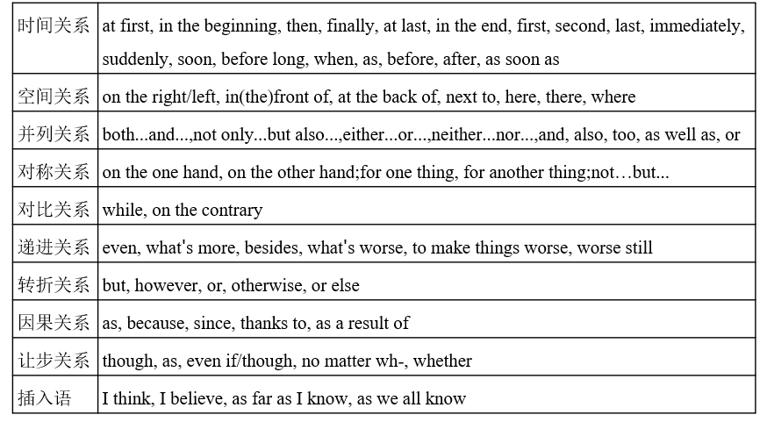
（B级）Some advanced expressions:
一、形容词短语作状语
1.He was desperate and hopeless ,and he knelt down, tears streaming down his face.
Desperate and hopeless , he knelt down, tears streaming down his face.(高级句式)
2.We were exhausted and hungry and we wondered if we could find our way back.
Exhausted and hungry , we wondered if we could find our way back.(高级句式)
二、使用非谓语动词
1.He felt disappointed and he had to stay alone for another night.
Feeling disappointed, he had to stay alone for another night.(高级句式)
2.A few days later, a young man came to the police station and said he saw the murder .
A few days later, a young man came to the police station, saying he saw the murderer . (高级句式)
三、强调句：
The young man stole the wallet yesterday.
It was the young man that/who stole the wallet yesterday.(高级句式)
四、倒装句：
He was so forgetful that he sometimes forgot what he was talking about in the middle of a sentence.
So forgetful was he that he sometimes forgot what he was talking about in the middle of a sentence.(高级句式)
五、定语从句：
1.I have organized many activities and they have improved my organizational skills.
I have organised many activities ,which have improved my organizational skills.(高级句式)
2.I came across my middle school teacher and he remained humorous and good-looking.
I came across my middle school teacher, who remained humorous and good-looking.(高级句式)
六、with复合结构：
He had nothing in his hand, so he had no idea how to scare the wolf away.
With nothing in his hand, he had no idea how to scare the wolf away.（高级句式）
课后反思：
________________________________________________________________________________________________________________________________________________________________
Homework：
1. Polish your continuation writing.
2. Review what we have learned today.

读后续写
●Teaching aims：
1) understand the plot through analyzing and discussing structure of the passage（A级）
2) summarize the main steps and methods to write a continuing story（B级）
3) develop a reasonable ending to a story by referring to the content of the text and using some advanced expressions.(C级)
On a bright, warm July afternoon, Mac Hollan, a primary school teacher, was cycling from his home to Alaska with his friends. One of his friends had stopped to make a bicycle repair, but they had encouraged Mac to carry on, and they would catch up with him soon. As Mac pedaled (骑行) along alone, he thought fondly of his wife and two young daughters at home. He hoped to show them this beautiful place someday.
Then Mac heard quick and loud breathing behind him. “Man, that's a big dog!" he thought. But when he looked to the side, he saw instantly that it wasn’t a dog at all,but a wolf, quickly catching up with him.
Mac’s heart jumped. He found out his can of bear spray(防熊喷雾剂罐). With one hand on the bars, he fired the spray at the wolf. A bright red cloud enveloped the animal, and to Mac's relief, it fell back, shaking its head. But a minute later, it was by his side again. Then it attacked the back of Mac's bike, tearing open his tent bag. He fired at the wolf a second time, and again, it fell back only to quickly restart the chase（追赶）。
Mac was pedaling hard now. He waved and yelled at passing cars but was careful not to slow down. He saw a steep uphill climb before him. He knew that once he hit the hill, he’d be easily caught up and the wolf’s teeth would be tearing into his flesh.
At this moment, Paul and Becky were driving their car on their way to Alaska. They didn’t think much of it when they saw two cyclists repairing their bike on the side of the road. A bit later, they spotted what they, too, assumed was a dog running alongside a man on a bike. As they got closer, they realized that the dog was a wolf. Mac heard a large vehicle behind him. He pulled in front of it as the wolf was catching up fast, just a dozen yards away now.
注意：
1. 所续写短文的词数应为150左右；
2. 续写部分分为两段，每段开头语已为你写好；
Paragraph1:
The car abruptly stopped in front of him.
___________________________________________________________________________________________________________________________________________________________________________________________________________________________________________________________________________________________________________________________________________________________________________________________________________________________________________________________________________________________________________________________________________________________________________________________________________________________________________________________________________
__________________________________________________________________________________________________________________________________________________________________________________________Paragraph2:
A few minutes later, the other two cyclists arrived.
______________________________________________________________________________________________________________________________________________________________________________________________________________________________________________________________________________________________________________________________________________________________________________________________________________________________________________________________________________________________________________________________________________________________________________

